CMPSC 390 – Homework 2
Project Design & Responsibility Breakdown
Objective
In Lab 2, your team defined what you are building.
In this assignment, you will focus on how the system will work and who is responsible for each part.
You should already have from Lab 2:
• A defined project idea
• A list of proposed features
• A general direction for your application

Step 1: Divide Responsibilities (Group)
As a team, decide how work will be divided for planning and design.
Most teams will divide responsibilities into areas such as:
• Frontend planning Alberto Esparza: Customer build page, browsing inventory, General design, Html Coding)
• Backend logic planning Charles Zufan and Ari(Login logic, authentication, handling, employee, and customer access, server routes.)
• Database design Francisco Garcia Jr. Database design (MySQL schema for users and roles, vehicles, custom builds, options, employee data)
You may divide responsibilities however you prefer, but:
• Every team member must have a clear responsibility
• Responsibilities must be documented
Deliverable:
• A short list mapping team members → responsibility areas

Step 2: Select Three Core Features (Group)
From your existing feature list (Lab 2), select three features to design in detail.
These should be:
• Central to your application
• Realistic to build during the semester
Deliverable:
• Names and brief descriptions of the three selected features

Customization: (Car type(sedan, suv, truck), wheels, rims, paint job, engine type, exhaust, interior, exterior)
User login (will require information of name first and last, username, password, birthdate, zipcode)
Parts and Pricing estimates (list parts, with pricing, availability)

Step 3: Frontend Design (Individual)
The team member(s) responsible for frontend planning must create wireframes for how users will interact with the system.
Requirements:
• At least three wireframes
• One must be the home or landing page
• Navigation between pages should be clear
• Visual consistency across screens
Deliverable:
• Wireframe diagrams
• Contributor name(s) listed
https://drive.google.com/file/d/1PkT-3NzYWiqvBNn6TiQKoqslWcmwL7tb/view?usp=sharing

Step 4: Backend Logic Design (Individual)
The team member(s) responsible for backend planning must write pseudocode for the three selected features.
Each feature should describe:
• User action
• Backend logic
• Database read and or write
• Response returned to the user
Pseudocode should be:
• Language-agnostic
• Clear enough for another developer to implement
Deliverable:
• Pseudocode for three features
• Contributor name(s) listed : Charles Zufan
#Feature 1: User Login
#User action: User enters username and password and clicks Login
def login(username, password):
#Database read
user = db.select_one("SELECT * FROM User WHERE Username = ?",username)
#Backend logic for login and response to user
if user is None or user["Password"] != password:
return "Login failed"
return "Login successful"
#Feature 2: Car Customization (Save Build)
#User action: User selects base car and parts and clicks Save Build
def save_build(user_id, base_car, part_id):
#Database read
part = db.get_part(part_id)
#Backend logic for DB
total_price = part.price
#Database write
db.save_custom_car(base_car, total_price, part_id, user_id)
#Response returned to user
return "Build saved"
#Feature 3: Parts & Pricing (View Parts List)
#User action: User clicks Browse Parts
def view_parts():
#Database read
parts_list = db.select_all("SELECT * FROM Parts")
#Response returned to user
return parts_list

Step 5: Database Design (Individual)
The team member(s) responsible for data design must define how data will be stored to support the three selected features.
Choose one approach:
Relational Database
• Tables and relationships
• ER diagram
NoSQL Database
• Document structure
• Mock data layout
• Diagram or structured explanation
Deliverable:
• Diagram and explanation
• Contributor name(s) listed
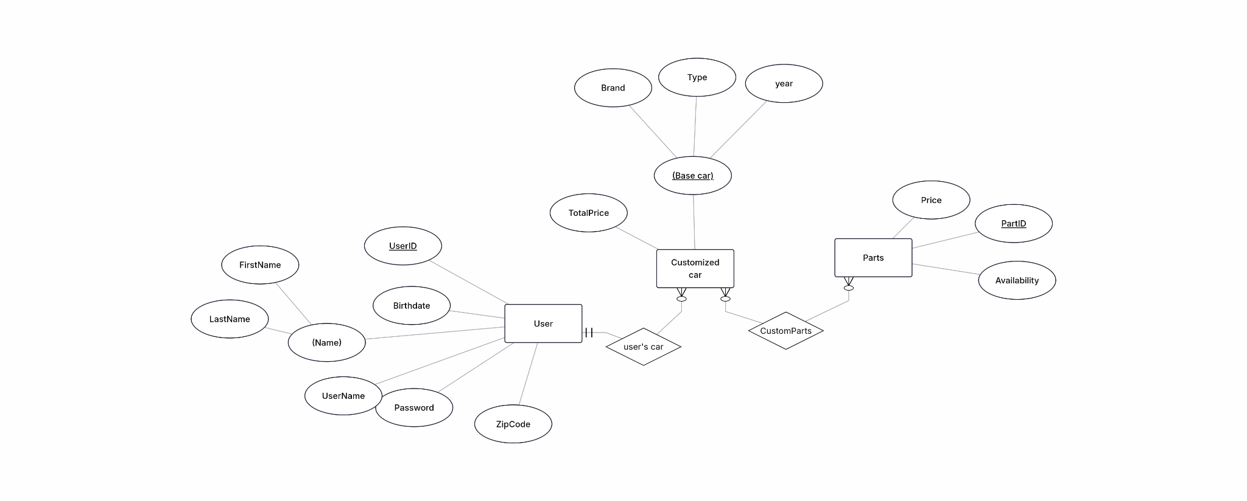
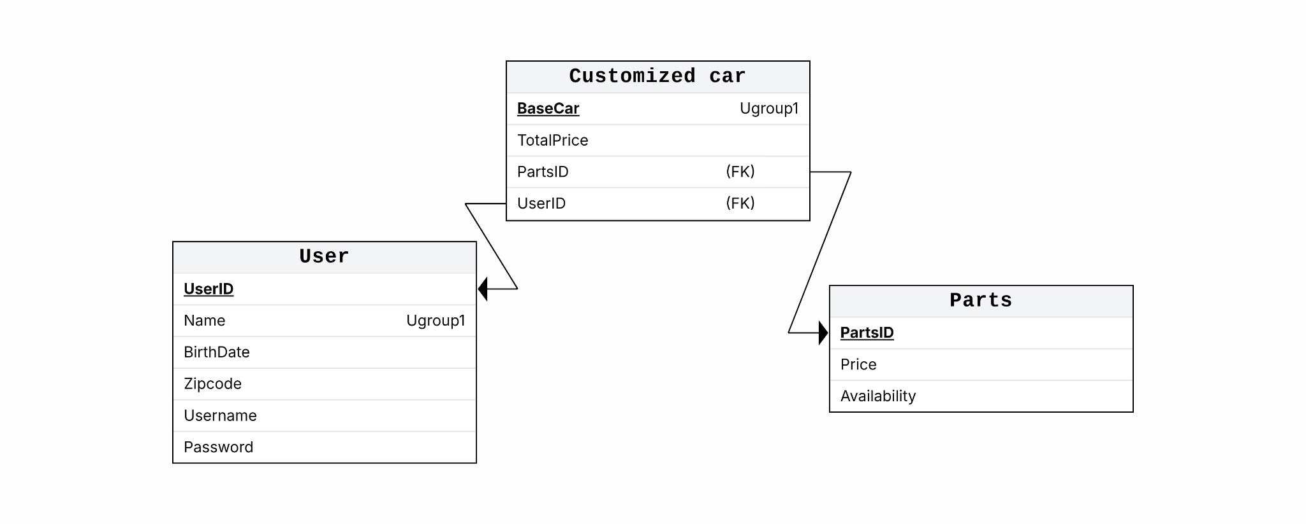

Step 6: Tooling & Hosting Setup (Group)
As a team, ensure the following are set up:
• One GitHub repository with all members/instructor added: Done
• One project board (Trello or equivalent): Done
• One communication method selected: Done
Instructor access required:
• GitHub: @williamburbatt
• Trello: @williamburbatt2
In addition, identify one potential hosting approach for your project.
• Research only
• No deployment required
Deliverable:
• Short write-up describing the hosting option
Legacy Auto co is a web application that is designed to allow users to create customized automobiles. Our company will code the features for an account system, allowing users to save their custom creations so that they can choose to view them at any time. We’ll also code in a feature that calculates the cost of all modifications, which can be bought individually, or have a service fee added if the user wishes to have Legacy Auto build it for them. All information regarding the stock/price of parts, user information, and each customized car will be stored in databases. Of course, the user will only have to navigate through the webpage itself, which has been detailed in the wireframes. The website will allow users to seamlessly transition between each of our key features, ensuring a good user experience. The plan is to take what we’ve laid out in this homework, and transform it into an actual webpage, allowing users to walk through the experience of building the automobile of their dreams.

Submission Requirements
One submission per team by the Project Manager.
Your GitHub repository must include:
• A documentation folder containing:
• Responsibility breakdown
• Frontend wireframes
• Backend pseudocode
• Database design
• Hosting notes
Submit in Canvas:
• Link to the team GitHub repository

